TimeSprite

Status Reports and Project Submissions

Date: 24/10/2016 to 16/11/2016

University of the Pacific

COMP 191, Senior Project, 2016 Fall ---Yunpeng Zhang

Contents

2 Project Schedule 2

3 Currents Status 3

3.1 Finished Tasks 3

3.2 Falling being schedule 3

4 Plan for next work period 4

4.1 Task for next work period 4

5 Challenges and concerns 5

6 updated artifacts 6

# Project Schedule

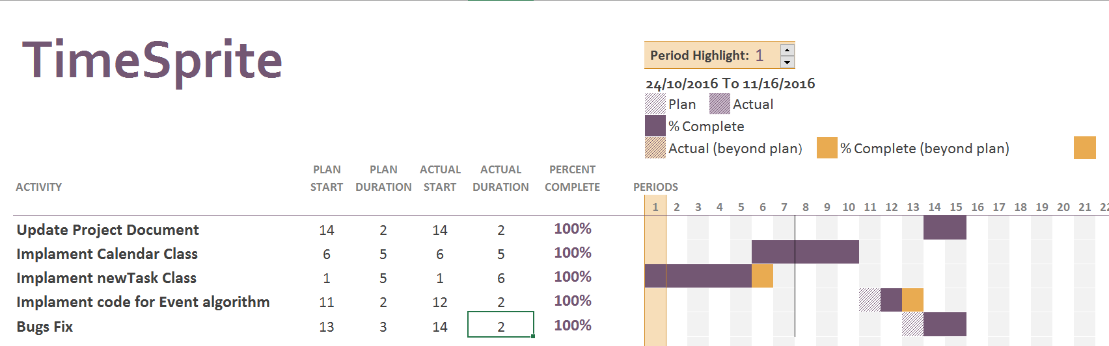

# Currents Status

## Finished Tasks

1. Update Project Document
   1. Fixed some spell and grammar problems
   2. Update new interface and interface interaction diagram
2. Implement newTask class
3. Implement generateCalendar Class
4. Implement Calendar Calss
5. Bugs Fix

## Falling being schedule

All Tasks finished, but overdue few days. Because implement code spent a lot of time.

# Plan for next work period

## Task for next work period

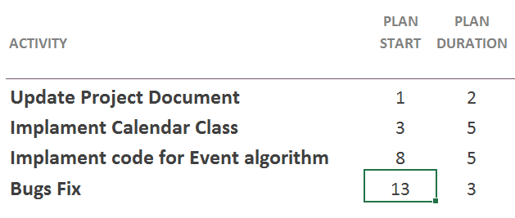

# Challenges and concerns

In last three weeks, I update all code into Swift 3.0 format. It caused a lot of problem and bugs. I found a critical bug which will cause memory leak and program crash during working. It took a lot of time to find the reason and fix. I asked my friend who has the experience with Swift 3.0, and work with him to fix this bugs. This is the reason why I didn’t finish one task on time. The remain work will move to next sprint, and I will continue work on it.

# updated artifacts

1. Some grammars and spells correction on documents.
2. Application Source Code
3. Gantt Chart
4. Next sprint plan